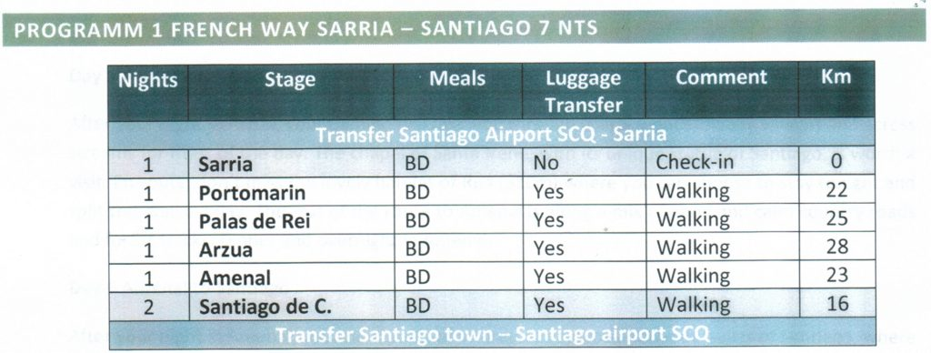
Download printable PDF itinerary
May 27 – Depart USA
If don’t doing own air arrive Santiago, Spain on the 27th. Then meet the group at airport on May 28 to transfer to Sarria. The group lands 840AM May 28.
May 28 – Group Transfer From Santiago to Sarria (Land portion officially begins)
Arrive in Santiago. At 2 pm we will be met and transferred 90 minutes to Sarria. We then begin our adventure in Sarria, high on the ridges of the Galicia peninsula of Spain. It is the largest town we will see as we begin our pilgrimage. By ancient Galicia standards, Sarria is a new city. But yet, it is charming in it “new” way. Sarria is
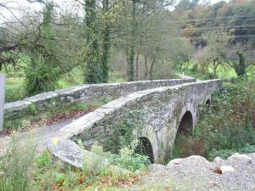
known for its impressive churches and monasteries, most dating to the 13thcentury.
Use your free time to explore and see the city’s wonders such as the church O Salvador, which is located on Rúa Maior. Equally important is the Convent of A Madalena that in the 13thcentury was used as a pilgrim hospital by Italian monks of the Order of the Blessed Martyrs of Jesus. Sarria is a city with a rich artistic history and is now considered a capital of antiques. From furniture to art, people flock to Sarria.
Our hotel is the Hotel Alfonso which overlooks the Sarria River and is a short distance from the town plaza. You will have the afternoon and evening to relax and explore to prepare for the journey that lies ahead. Sarria is a foodie haven, so enjoy some of the local cuisines. The specialty if a stew called cocido which is a mixture of wild game and seafood. Bear in mind this is the starting point for many on this pilgrimage so you may meet others who are there for the same reason as you.
Overnight: Sarria – Hotel Alfonso D
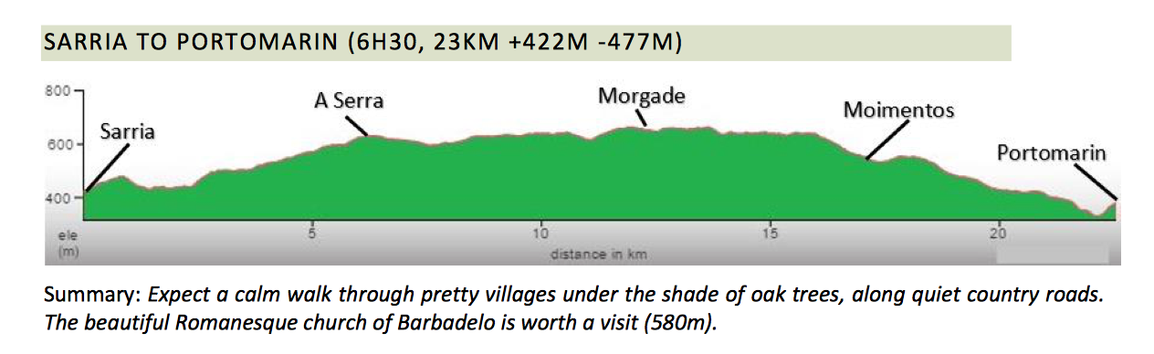

Mar 29 – Sarria to Portomarin
Following a hearty breakfast, we set out through Ponte Ribiera on what is about a peaceful 13 ½ mile walk through pretty villages and peaceful hamlets. As we exit town, we pass the Magdanela Convent and then head along quiet country roads that are shaded by oak trees. You will see a constant reminder that you are on the right path by the scallop shell symbols along the way. The shells are found on trees, roads and signs, pointing the Way. Medieval pilgrims wore the shells while traveling the path to symbolize their journey.
Along the way, you will spot many Galician traditional ‘hórreos’ (granaries). As we pass through the tiny town of Barbadelo, make sure to take time to see the beautiful Romanesque church in the village of Barbadelo with its incredible baroque altar. Other small hamlets we traverse include Rente, Serra, Peruscallo, Morgade,
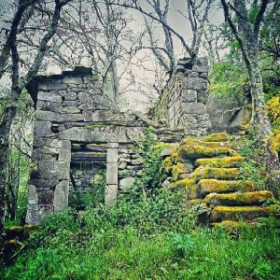
Mercadoiro and Vilache. Each provides an opportunity for you to rest, have a snack or look around.
As we make our final steps to Portomarin, you will see a set to ancient steps and a structure known as the Chapel of the Clouds… this is the best and traditional way for pilgrims to enter Portomarin. The town has many cute shops and restaurants but you should take time to visit the church of the Knights of the order San Juan. It is both a temple and a fortress. Once located in the Miño River Valley before it was flooded as a dam reservoir, the structure was moved stone by stone and reconstructed here.
We’ll check into Poussada de Portomarin overlooking the Miño River and very close to the church of San Juan. If you really want to go local this evening, try a traditional meal of fried eels!
Overnight: Poussada de Portomarin B/D
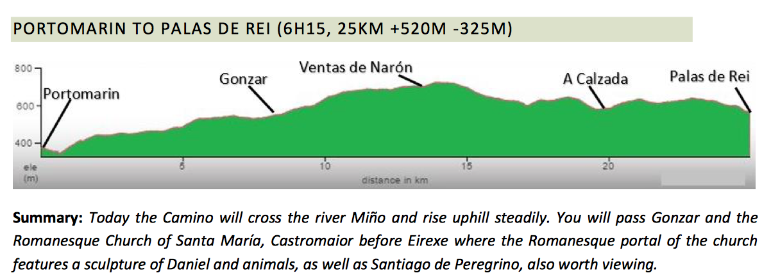
May 30 – Portomarin – Palas de Rei
When we leave Portomarin, your Camino will cross the river Miño (Galicia’s longest river) and begin a steady slope uphill towards the Serra de Ligonde. Today ’s venture will cover about 15 miles through varied terrain. We’ll start in shaded forests and then go along some paved roads past hamlets such as Gonzar, Hospital de la Cruz and Ventas de Narón. Hospital de la Cruz was named after on old hospital for pilgrims which no longer exists. It is believed to be the site of a massive Christian – Moorish battle in the 9thcentury.
There are several churches worth stopping at along the way, but perhaps the one you should not miss are the Romanesque Church of Santa María in Castromaior and the Romanesque church in Eirexe, with its portal featuring a sculpture of Daniel with animals, as well as Pilgrim Santiago. We end today’s journey in the town of Palais de Rei. Among the places you should take in is Castillo de Pambrewhich is the most complete Medieval Fort in Galicia, dating from the 14thcentury.
Your evening is free. When dining, you may want to enjoy some of the soft cheeses the area is known for. We will be overnight at Complejo la Cabana, a log cabin hotel along the route which is within walking distance the center of town
Overnight: Palas de Rei – Complejo la Cabana B/D
Castillo de Pambre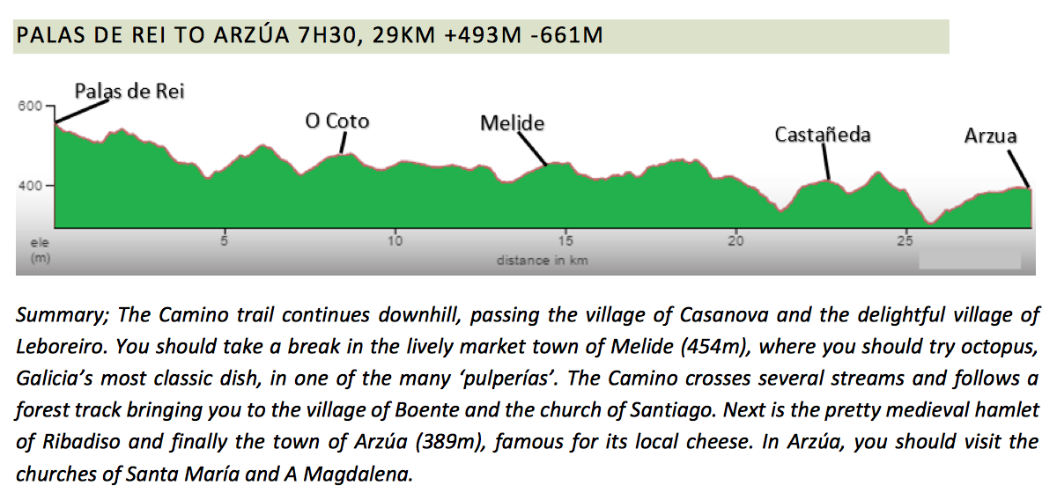
May 31 – Palas de Rei – Azúra
Today will be your longest hike, traveling about 18 miles. The good news is that today is mostly downhill. Our path will take across the border between the province of Lugo and La Coruña. We will be passing through the village of Casanova and the delightful village of Leboreiro. You should take a break in the lively market town of 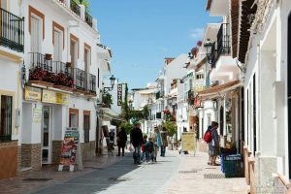Melide, where you should try octopus, Galicia’s most classic dish, in one of the many ‘pulperías.’ After Melide, you will notice that the Way will start becoming more crowded as we merge with the Primitive Road
The scenery here can be breathtaking as we follow the Castasol River, crossing several streams. We’ll make our way along a forest track of eucalyptus and oak, bringing us to the village of Boente and the church of Santiago where the parish priest enjoys beckoning travelers to come in for a visit. Next is the pretty, medieval hamlet of Ribadiso and finally the town of Arzúa which connects to the Camino in the North. During your free evening, you should visit the churches of Santa María and A Magdalena.
We overnight at the Casa Teodora, located right on the Camino. Recently renovated, the same family has run this pension for more than 100 years, catering to the needs of pilgrims.
Overnight: Arzúa – Casa Teodora B/D
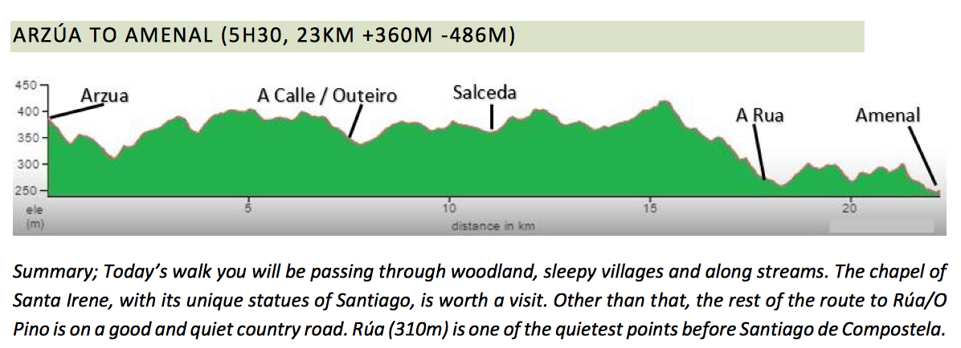
Jun 1 – Arzúa to Amenal
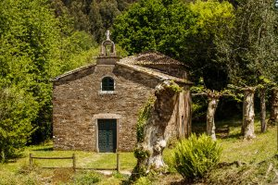
Today’s Camino will take us for about 14 miles through pretty woods, sleepy villages and across streams for most of the day. This is an easy trek and one that can be enjoyed by stopping for drinks and snacks in the various scenic hamlets along the way. You’ll notice that the closer you get to Santiago, the more joyous everyone’s spirit is and the more social the other pilgrims have become.
In the town of Santa Irene, the chapel of Santa Irene is worth a visit. It is said Irene was murdered here but that the image of the Saint inside the shrine has healing powers. The nearby fountain is claimed by some to be the Fountain of Eternal Youth.
The lovely hamlet of Rúa is an overnight spot for many but we will continue on along country roads and forest tracks to Amenal. We will overnight at the hotel Amenal, A modernized historic structure, it overlooks fields and forests but yet is convenient for exploring this little town.
Overnight: Hotel Amenal & Hotel Bello Castrofeito B/D
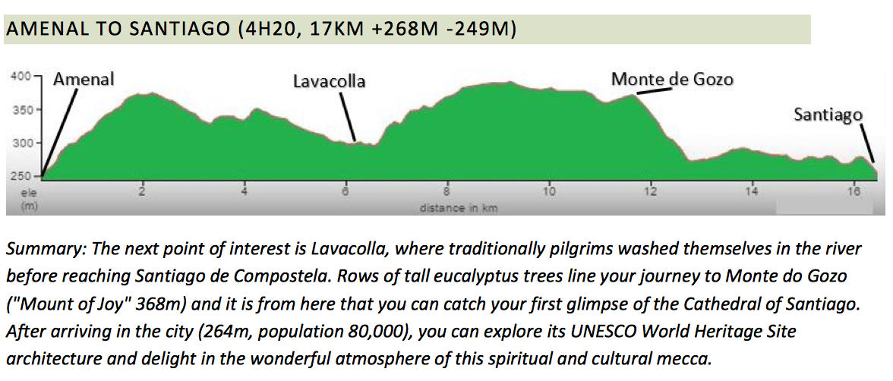
Jun 2 – Santiago de Compostela
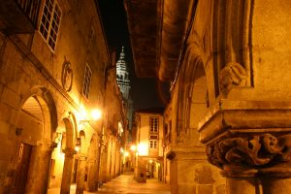Savor every moment of the last 10 miles of our epic pilgrimage. We will stop in Lavacolla on the outskirts of Santiago where for centuries pilgrims would come to wash in the waters on the river in preparation for their arrival in Santiago de Compostela. A shaded path of rows of tall eucalyptus trees line your journey to Monte do Gozo or Mount of Joy. From here we will catch our first glimpse of the spires of the cathedral in Santiago.
From here, we will be entering the city of Santiago and make a short walk to the historic part of Santiago and the Plaza del Obradoiro which is the town’s main square. we must register our arrival with the Pilgrims’ Office to make out pilgrimage completion official. We will then we enter the Cathedral itself to be a part of the Pilgrim mass. Held at noon, the mass begins with the reading out of the number of pilgrims who have been received in the Pilgrims’ Office in the last 24 hours, where they come from and where they started their pilgrimage. We then collect out certificates of completion.
Afterward we can check into a property everyone loves, the San Francisco Monumento, a historic hotel that will give you well deserved pampering after your journey. We have the afternoon to explore quaint pedestrian streets of this gem of an ancient city which is a UNESCO World Heritage Site. Known for its architecture and delightful atmosphere of spirit and culture, y9u will find not only pilgrims but also locals and students, enjoying a few bites and socializing over a glass of wine in the many bars, restaurants and cozy cafes.
Overnight: San Francisco Monumento B
Jun 3 – Explore on own or join on or Optional Finisterre Day Tour!
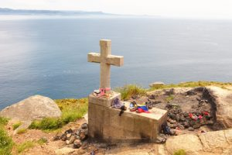Finisterre Day Trip Tails located in the lighthouse at Cape Finisterre, where pilgrims burn an object that led to the Camino Santiago, the end of pilgrim route to Santiago de Compostela.
Free at last. AFSers love Leisure time!
You have a free day to rest up or explore Santiago de Compostela. The San Francisco Monumento is a property with indoor and outdoor pools. And of course, the city itself is known for its pedestrian areas lined with shops and cafes. The local daily market is photo-worthy – filled with colorful fruits, vegetables, cheeses, seafood and wares.
Optional: You also have the opportunity to take an optional visit to Finisterre (or Fisterra in Spanish), the “End of the World.” Traditionally, pilgrims used to finish their Camino journey in Cape Fisterra, where they burned their clothes and admired the sun setting over the Atlantic Ocean. This tour will take us to the coast which is known for its rugged cliffs, golden beaches and small fishing villages. The views here are spectacular! We will make stops at the formidable Costa da Morte, the small fishing village of Muros, Carnota (home to the biggest granary in Galicia and the largest sandy beach), and the village of Muxía, famous for its charming sanctuary by the Atlantic. We will also visit the stunning Ézaro waterfall – the only river in Europe reaching the sea as a waterfall. (60 Euros – details later)
Overnight:San Francisco Monumento B/D
Jun 4– After breakfast, depart to airport.

-BOOK NOW if trip full, then WAITLIST
This small group, limited to 28 will sell out fast. This is on a lot of people’s bucket list. AFSers are begging us “Please do The Way” so do not delay!!!
Fitness level – 2-3 Five days hiking. Averaging 4 to 7 hours walking at your own pace daily. Total 110 km. More in Trip Tips
Land Price 1220 Euros (at today’s rate around $1430)
Deposit $500
Included:
- 7 nights hotel accommodation with breakfast and dinners
- Long haul airport transfers – Santiago to Sarria
- Expert English speaking walking guides
- AFS GTL
Not included: Gratuities ($80)
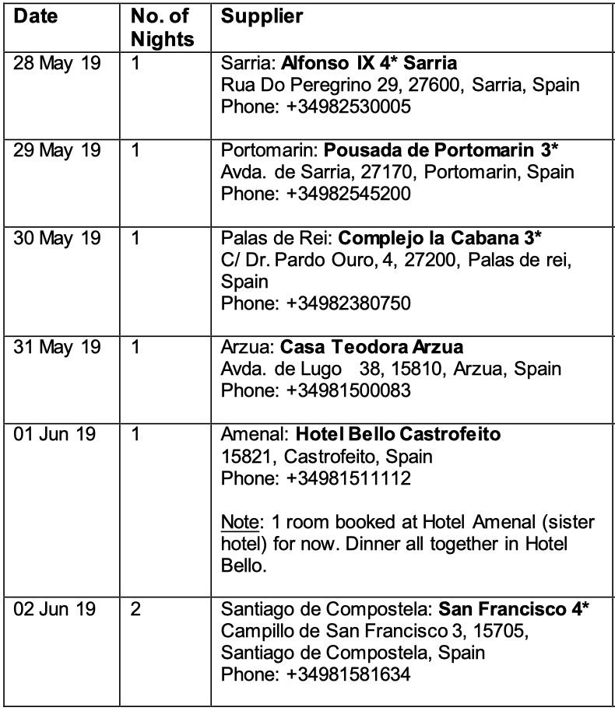
All prices are per person twin share. Single rooms limited per group and a single supplement applies. Cost set by hotel/cruiseline and vary considerably. AFS will find you a roommate match. Please review AFS Terms and Conditions as well as Heading Abroad with AFS.
Land – Price based on a minimum number of trip participants, as well as local currency exchange rates which can fluctuate. We write our Itineraries a year in advance. Though unlikely, we reserve the right to modify schedules, tours and hotels if necessary. All hotel rooms are “run of house.”
Group air – Airlines may add surcharges to offset fuel inflation or taxes. The total ticket cost is not final until we receive your final payment and the group is ticketed. If doing own air, airport transfer may or may not be included depending on your air schedule. Do not buy air until the group air is set or we advise – though unlikely, airlines, times and dates can change!

